Contents

1.  Introduction. - 15  min 2

2.  Interactions with TEAM mates -30 min 3

Mr. Suresh Krishnamurthi 3

Mr. Jayakumar (Dir Manufacturing) 3

Mr. S.R. Radhakrishnan (Manu & Fabrication) 3

Mr. K.U. Ratish (BD & Marketing) 4

Mr. Nand Kumar (Contract & PM) 4

Mr. Partibhan (Finance) 4

3.  Review of existing facility/systems to analyze the gap. - 45 min 5

Planning (estimation, scheduling, budgeting, baseline, who does what and when and how) 5

Document Management 5

Communication Management 5

Vendor Management (raw material) 6

Vendor & Contract Management 6

Cost/Expense/Invoice Management 6

Material Management 6

Dependency Management 6

Quality Management 6

Change Management 6

Knowledge Management (Org / Project Level) 6

Issue / Conflict Management 6

Risk Management 7

Daily Work Tracking, Impact Assessment, work authorization 7

Utilization, Productivity, Motivation, Conflict Management 7

Stakeholder Engagement 7

4.  PMO as a Solution- 30 min 7

5.  Review of existing manpower/capabilities for PMO – 45 min 7

6.  Understanding the training needs and freezing of training date along with the participants.   - 30 min 7

7.  Questions & Answers (QA) session. -15 min 7

8.  Action plan for the implementation including the establishment of PMO. - 30 min 7

9- Infrastructure, Budget & Commercial for PMO 10

Cost of Hardware/Software 10

Cost of Consulting Services 10

Human Resources 10

Project Board Room 11

**Understanding PMO Requirements**

**Titanium Equipment and Anode Manufacturing Company Ltd. (TEAM)**

**Discussion Date: 20-Sep-17, 12 PM - 6 PM**

# 1.  Introduction. - 15  min

1. Mr. Suresh Krishnamurthi Rao (Chairman)
2. Mr. V Raghu Raman (VP)
3. Mr. Jayakumar (Director Manufacturing)
4. Mr. S.R. Radhakrishna (Manu & Fabrication)
5. Mr. K.U. Ratish (BD & Marketing)
6. Mr. Partibhan (Finance)
7. Mr. Nand Kumar (Contract & PM)
8. Mr. Hari P Thapliyal (PMO Consultant)

**Departments & Owners**

1. Director Manufacturing – Mr. Jaikumar
   1. Fabrication – Mr. S.R. Radhakrishanan
   2. Maintenance – Mr. K. Vajravelu
   3. Design – Mr. Linganathan / Gopal Krishnan
   4. PPC (Production Planning & Control) – Mr. Jai Chitra
   5. Procurement – Mr. A Venugopal
      1. Store – Mr. Dhanaraj
   6. Sub-Contracting – Mr. S P Nagarajan
   7. Human Resource – Mr. Senthil
2. Sales & Marketing/ Contract – Mr. KU Ratheesh / P Kumareshan
   1. Proposal/Estimation – Mr. P Elangovan
3. Quality Control – Mr. B Soundar Rajan (BSR)
4. Finance & Accounts – Mr. R Ranganathan
5. EDP – Mr. J S Kumar
6. PMO – Mr. Nand Kumar

# 2.  Interactions with TEAM mates -30 min

Understand the requirement from technical/commercial team (all key stakeholders)

**Name/Role/Expectations from New Initiative**

## Mr. Suresh Krishnamurthi

* I need to get involved at micro level to get the work done. It kills my lots of productive time.
* Project team does not have data to substantiate what they are saying or the decisions made
* Project data is not being captured on regular basis
* Not possible to forecast resource need for next quarter
* I want a system which is indicator based and tells me which project is doing good/bad in terms of cost, time, scope, risk, quality, benefits etc. This system should be easy to understand. If possible one page for entire organization.
* A system is required to know the resource capacity, utilization at organization level so that timely decision can be made for managing resources and cost.
* There are 60 Jobs/ Project now with us. More are in queue but we cannot handle them with today’s state of project management capability.

## Mr. Jayakumar (Dir Manufacturing)

**Challenges**

* Each job needs different skills
* Capability/skills of each persons is different and not being used
* Utilization of resources is not at right level.
* Before Project starts somebody need to validate estimates (cost/time). It is not happening as of now.
* Business Development assumes that material is available, without asking to the production

## Mr. S.R. Radhakrishnan (Manu & Fabrication)

**Challenges**

* We make product for different industry so different kind of processing is required for the same product.
* Each order is unique so it is project.
* Processing Cycle for each order is different
* Design & Material takes 70% of the time. Because special material need for the project. This leads to less time for production/manufacturing.
* Different machines required for different projects. It is not feasible to purchase machines for every need but when we give work to the supplier then they want business commitment. In this situation, it becomes difficult to deliver on time.
* Short time for procurement.
* Genuine Sub-contracting is difficult for equipments.
* To reduce time if we purchase from other market then transport cost is high for last moment airlifting.
* To reduce cost if we procure from a low-cost market then transport cost is so high that it beats the purpose or time is more for shifting.

**Solution**

* Each work in the project should finish on time so that fabrication can be finished in the time allocated for it.
* Lack of infrastructure leading to cost and schedule overrun, so, think about acquiring some infrastructure.

## Mr. K.U. Ratish (BD & Marketing)

Experience of Automobiles Industry

We have MS Project (3 License, 2010)

**Challenges**

* CTQ (Critical to Quality) (Cost overrun, Delivery date missed, Scope is not problem, Margin get wiped out)
* Customer Delivery Date is fixed, so we do not have option of negotiating time.
* Cost of component is fixed in the market so difficult to negotiate the price with potential customer.
* Production is not happening as per the schedule and this lead to project delay
* More time spend on the project leads to more cost, it is worse. Is it possible to let the schedule move without effecting cost?
* Supplier not meeting their commitments
* Team is doing multitasking so they do not know what to prioritize and it leads to delay of critical activities
* Student syndrome & Parkinson Law are extending the time lines on the project.

## Mr. Nand Kumar (Contract & PM)

New to PM & PMO function.

* Nand Kumar Makes Project Plan of the project. Work estimate is done based on the "previous experience" of organization. Scheduling is done based on the project end date.
* Department functions related to the project are not completing their work on time
* How to deliver the project on time if we miss some milestone (catchup plan)

## Mr. Partibhan (Finance)

**Challenges**

* Cash-flow management is problem. Sometimes money is asked at the time when it is not available.
* Milestone level cost variances exists for projects
* Explore the option of JIT (Reduce inventory size)
* Manage slow moving & non-moving inventory in a better way
* Manpower Utilization (for casual labor) should be better.
* Resource Forecast need to be prepared based on the business projection.
* Tracking of available hours/ allocated hours/ actual hours of resources on regular basis
* Zero LD (liquidated damage) causing loss in the project

**Solution:**

* Categorize projects as <1 Cr and >1Cr. And use LD practices.

# 3.  Review of existing facility/systems to analyze the gap. - 45 min

**Processes, Systems, Tools, People**

## Planning (estimation, scheduling, budgeting, baseline, who does what and when and how)

* Proposal & estimation team does estimation. Estimates are not validated in PLC.
* PM is not doing estimation
* PM makes schedule
* Baseline (only scope NOT cost/time/benefits/quality)
* Resource Optimization (manually, so it not proper)
* No one is accountable for project level/ milestone variances of project objective.
* Department takes responsibility of variances in their work but no action/learning takes place either in project or org level.

## Document Management

* At department level only.
* At the time of delivery compile all documents, perform inspection/final witness and send to customer & QC. PM ensure the compiled document has been sent.

## Communication Management

* Contracts department manages all the communication with customers and all functions.
* Client wise communication matrix exists and reporting formats are used to communicate

## Vendor Management (raw material)

* Procurement department manages.
* DB of vendors and their products exits.
* Procurement team has goal to save money on procurements.
* PM puts requirement and spes/timelines/cost before procurement team. They need to procure as per the need.

## Vendor & Contract Management

* Procurement & Sub-contracting department

## Cost/Expense/Invoice Management

* Cost tolerance limit & authority level exits
* Cost overrun approval from MD
* Order approval by Finance team -> Quality approved by Quality team -> Material approval by Material team -> Payment approval by Finance team
* Import Material approval by MD
* Why do you take approval after baseline has been approved and work is within tolerance limit?

## Material Management

* Material department

## Dependency Management

* Individual departments are managing between themselves.

## Quality Management

* Quality department.

## Change Management

* Raise deviation to customer. Customer approves.
* change management process exists
* CCB approves the changes based on the vested authorities

## Knowledge Management (Org / Project Level)

* No system exists as of today.

## Issue / Conflict Management

* Systems are existing but they are related to the processes/functions.

## Risk Management

* Not formally in place.

## Daily Work Tracking, Impact Assessment, work authorization

* Not in place

## Utilization, Productivity, Motivation, Conflict Management

* Functional manager or HOD

## Stakeholder Engagement

* Material dept. managing Vendors
* PM managing Customer/Functional head.

# 4.  PMO as a Solution- 30 min

Presentation (separate file)

# 5.  Review of existing manpower/capabilities for PMO – 45 min

     To explore the possibility of creating/establishing a PMO Office with the available resources.

# 6.  Understanding the training needs and freezing of training date along with the participants.   - 30 min

* A training on Fundamental of Project Management + EPM & MSP- 6 days. (Discussing Team’s business case and trying to solve problem in logical way)
* **Proposed Date: 6-12 Oct (Week)**

# 7.  Questions & Answers (QA) session. -15 min

# 8.  Action plan for the implementation including the establishment of PMO. - 30 min

1. Decide PMO head, Project Managers, Project Management Team members from various departments (TEAM)
2. Conduct a 3 days workshop on fundamental of project management (9-13/Oct’17)- Hari/TEAM
3. Conduct a 3 days workshop on MS-EPM enterprise project management & MSP (Microsoft Project) tools (9-13/Oct’17)- Hari/TEAM
4. Refine roles, responsibilities & accountabilities- Hari
5. Sit with each project manager & PMT and understand what they understood, what they are doing and what they are supposed to do.- Hari/PM/PMT
6. Install EPM tool - Hari
7. Select 20-30 critical projects and distribute those among existing project managers.- PMO
8. Project Managers prepares the plan for these projects and upload in EPM.- PM
9. PM & PMT start using the tool- Hari/PM/PMT
10. Design Project Management Dashboard for Senior Management- Hari
11. Project Management Process Design – Hari/PM/PMT
12. Implement the processes in the tool – Hari/PM/PMT

A suggested PMO structure. Subject to approval by chairman.

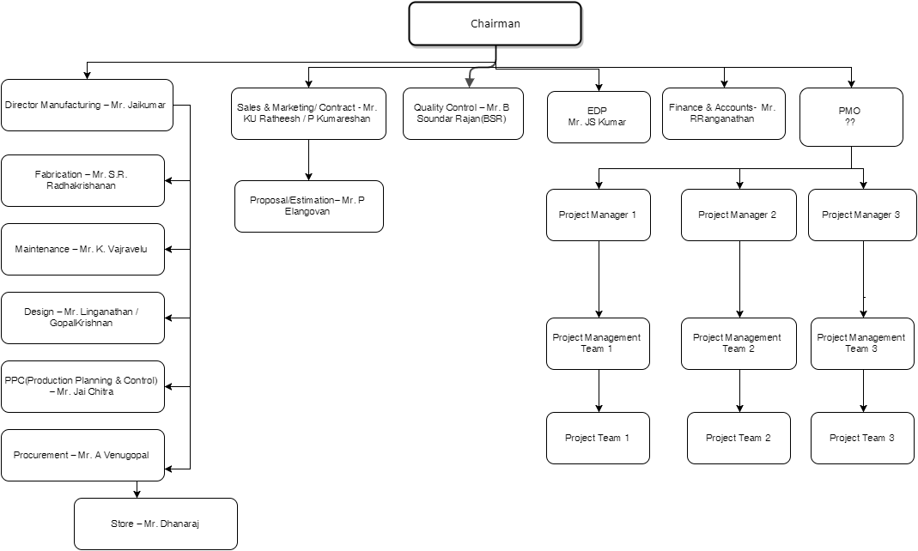

* 1. PMO Head, Project Managers, Project Management Team Members need to be identified by “TEAM”. This is important information for conducting training.
  2. **Accountabilities of PMO Head**
     + Optimum utilization of all kind of resource for allocated resources in various projects across the organization
     + Knowledge management
     + Project Management Methodologies/Process standardization
     + Project Audits (process, governance, tracking, document management, risk etc)
     + Ensure each project within TEAM get successfully done as per the commitment to customer and management.
     + Help project managers in planning
     + Project Governance
     + Reporting project progress to chairman on periodic basis.
     + First level escalation for PM
     + With the help of PMT and systems resolve across project dependencies
     + PMO is accountable towards the Chairman
     + Highest authority in project management to make decisions.
     + Helps presales/proposal team in validating estimate, capability, availability. No proposal should be submitted to customer without PMO head’s input consideration.
  3. **Responsibilities of Project Team (PT):** Project Team is delivery team, consisting of permanent employees from various departments or contract work force
     + Complete the work as per the plan
     + Report project progress/impediments on daily basis to the PM
     + If required, take technical help from PMT or his department
     + Report the actuals (cost, efforts, risk, issues) on the daily basis to the project manager
  4. **Who is Project Management Team (PMT)**
     + Project Management team is a team of people dedicated from functions for project coordination, estimation, estimating, verifying estimates, making commitment for project, making decision.
     + In a project no matter from whom they take inputs (peer, boss, junior, supplier) but they make the decision on behalf of their division.
     + These people should be always available to PM and project team.
     + These people form project planning and governance.
     + A member of project 1’s PMT can be member of project 2’s PMT.
     + Every project should have a dedicated PMT but members may not be dedicated for one project only.
     + PMT members are accountable to Project Manager
  5. **Accountabilities of Project Management Team (PMT) in Project**
     + Makes the decision in project of behalf of their department
     + Communicate with other members of PMT of the project
     + Communicate with other members of other PMT
     + Routine review with PM
     + Accountable for their decisions taken or not taken
     + Accountable towards PM
     + Ensure right skilled PT Members (PTM) are available for project
  6. **Accountabilities of Members of PMT in Function**
     + In consultation with their managers ensure employees are have desired skills to completing the work
     + Resource utilization of PT Members at organization level
     + Update resource plan and their utilization
  7. **Accountabilities of PM**
     + Coordinate with PMT and create a Project plan
     + Get project plan approved from appropriate authorities
     + Resolve day to day impediments directly or with the help of PMT
     + Completing each milestone and project within the cost, time, scope, quality, risk, benefit tolerance defined in project baseline
     + PM is accountable towards PMO

This is a high level set of accountabilities and responsibilities so that you can make decision who should fill those positions from various departments. I will prepare the same in detail during consulting exercise.

# 9- Infrastructure, Budget & Commercial for PMO

## Cost of Hardware/Software

<https://products.office.com/en-us/project/compare-microsoft-project-management-software?tab=tabs-1>

I suggest buying cloud version of Microsoft Enterprise Project Management (EPM). It is easy to scale (up or down) based on the need, easy to manage (security, maintenance, uptime etc). There is no upfront cost involved in acquisition, learning and installation.

* 2 Licenses of Project Online Premium – Total: $110/Month
  + For PMO Head & Chairman
* 2 Licenses of Project Online Professional- Total: $60/Month
  + For Project Managers
* 4 Licenses of Project Online Essential – Total: $28/Month
  + For Project Management team Members
* **Grand Total (Licenses): $198 /Month**

## Cost of Consulting Services

I suggest budgeting 50 days consulting work for next 6 months. Post 6 days training I will give you utilization plan of the reaming 44 hours. I do not think more than these hours will be required to bring the system in place. **Commercial for this 17K/Day + 18% Tax + Stay/Travel/Food/Printing** etc any other cost based on actual

## Human Resources

**PMO Head**

I suggest a senior person who can be either be completely freed or 80% freed from his current role and given the new PMO Head role will be ideal for this role. Get this person from your existing system. Either Ratish or Radhakrishnan can be suitable for this role. But Chairman need to negotiate the accountability of this new role with them keeping in mind that there should not be any conflict of interest in the PMO work and other work which they are doing.

For initial couple of month, if required, I can be there at Chennai location with PMO team. At this time, I am not able to foresee what kind of challenges can crop up and how much engagement may be required. Therefore, I am not mixing that effort with consulting work proposed above. But, if this is required then my **monthly commercial will be 3.4 L/months + 18% services Tax. It includes stay, travel, food etc.**

Because of some high urgency if I need to take some other training work or travel out of Chennai because of personal reasons (and if it possible to manage from existing TEAM work) then I would like to take leave for few days and in that case you can deduct 16 K/ Day less for the absent days.

**Project Managers**

Please identify 3-4 project managers for your 60 projects. To start with they will manage critical projects under the guidance of PMO Head and PMO Consultant.

If required we can hire 1-2 PM from market.

**Project Management Team Members**

Every department need to identify minimum 2-3 people from their department who can be part of project management team.

If required we can hire these people from the market but they should be part of some department.

## Project Board Room

A dedicated room where

* + We can put Kanban board for each project and update that on daily basis.
  + Project team can perform the daily standup meeting
  + Team can plan the work of the sprint
  + Share the ideas across the project, department and hierarchy